1.实验准备:

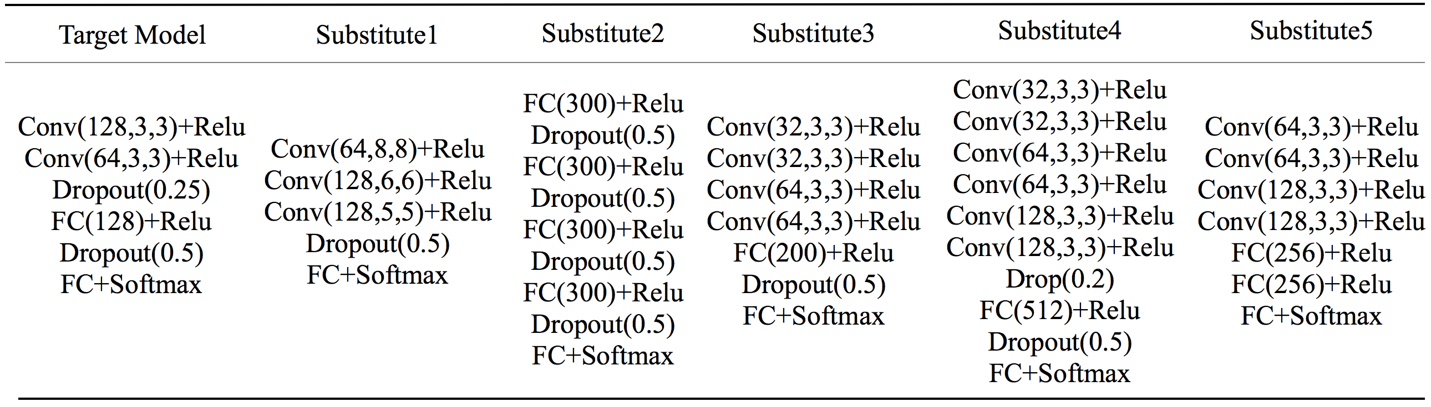

|  |  |  |  |  |  |
| --- | --- | --- | --- | --- | --- |
| Name | Training data | Test data | Features | Labels | Task |
| MNIST | 50000 | 10000 | $$28×28×1$$ | 10 | digit recognition |
| GTSRB | 39209 | 12630 | $$32×32×3$$ | 43 | traffic sign recognition |

2. MNIST数据集实验结果:

|  |  |  |  |
| --- | --- | --- | --- |
| FGSM($\text{α}\text{=0.1}$) | *accuracy* | *Success rate* | *Transfer rate* |
| Black-Box Model | 99.19% | -------- | -------- |
| Sub1 | 81.07% | 75.53% | 2.64% |
| Sub2 | 79.21% | 74.91% | 2.01% |
| Sub3 | 86.13% | 39.85% | 1.51% |
| Sub4 | 86.53% | 35.83% | 1.62% |
| Sub5 | 83.47% | 48.85% | 1.52% |
| Iter_Casc(k=3) | ---------- | **77.32%** | **3.69%** |
| Stack_Paral(k=3) | **----------** | **36.73%** | **2.47%** |

|  |  |  |  |
| --- | --- | --- | --- |
| I-FGSM($\text{α}\text{=0.1}$) | *accuracy* | *Success rate* | *Transfer rate* |
| Black-Box Model | 99.19% | -------- | -------- |
| Sub1 | 81.07% | 91.16% | 2.34% |
| Sub2 | 79.21% | 82.04% | 1.68% |
| Sub3 | 86.13% | 59.20% | 1.37% |
| Sub4 | 86.53% | 43.24% | 1.54% |
| Sub5 | 83.47% | 69.03% | 1.33% |
| Iter_Casc(k=3) | ---------- | **77.32%** | **3.69%** |
| Stack_Paral(k=3) | **----------** | **36.73%** | **2.47%** |

|  |  |  |  |
| --- | --- | --- | --- |
| R+FGSM($\text{α}\text{=0.1}$) | *accuracy* | *Success rate* | *Transfer rate* |
| Black-Box Model | 99.19% | -------- | -------- |
| Sub1 | 81.07% | 77.14% | 1.75% |
| Sub2 | 79.21% | 60.51% | 1.47% |
| Sub3 | 86.13% | 40.32% | 1.18% |
| Sub4 | 86.53% | 29.43% | 1.31% |
| Sub5 | 83.47% | 43.32% | 1.16% |
| Iter_Casc(k=3) | ---------- | **77.32%** | **3.69%** |
| Stack_Paral(k=3) | **----------** | **36.73%** | **2.47%** |

|  |  |  |  |
| --- | --- | --- | --- |
| FGSM($\text{α}\text{=0.}\text{2}$) | *accuracy* | *Success rate* | *Transfer rate* |
| Black-Box Model | 99.19% | -------- | -------- |
| Sub1 | 81.07% | 90.03% | 11.17% |
| Sub2 | 79.21% | 92.88% | 11.81% |
| Sub3 | 86.13% | 51.51% | 4.99% |
| Sub4 | 86.53% | 51.45% | 5.92% |
| Sub5 | 83.47% | 64.05% | 5.23% |
| Iter_Casc(k=3) | ---------- | **97.83%** | **20.54%** |
| Stack_Paral(k=3) | **----------** | **60.07%** | **16.25%** |

|  |  |  |  |
| --- | --- | --- | --- |
| I-FGSM($\text{α}\text{=0.}\text{2}$) | *accuracy* | *Success rate* | *Transfer rate* |
| Black-Box Model | 99.19% | -------- | -------- |
| Sub1 | 81.07% | 99.36% | 7.59% |
| Sub2 | 79.21% | 98.33% | 5.28% |
| Sub3 | 86.13% | 81.87% | 2.49% |
| Sub4 | 86.53% | 74.36% | 3.53% |
| Sub5 | 83.47% | 86.12% | 3.36% |
| Iter_Casc(k=3) | ---------- | **97.83%** | **20.54%** |
| Stack_Paral(k=3) | **----------** | **60.07%** | **16.25%** |

|  |  |  |  |
| --- | --- | --- | --- |
| R+FGSM($\text{α}\text{=0.}\text{2}$) | *accuracy* | *Success rate* | *Transfer rate* |
| Black-Box Model | 99.19% | -------- | -------- |
| Sub1 | 81.07% | 94.84% | 4.94% |
| Sub2 | 79.21% | 87.96% | 4.17% |
| Sub3 | 86.13% | 57.43% | 2.20% |
| Sub4 | 86.53% | 47.20% | 2.73% |
| Sub5 | 83.47% | 60.78% | 2.40% |
| Iter_Casc(k=3) | ---------- | **97.83%** | **20.54%** |
| Stack_Paral(k=3) | **----------** | **60.07%** | **16.25%** |

|  |  |  |  |
| --- | --- | --- | --- |
| FGSM($\text{α}\text{=0.}\text{3}$) | *accuracy* | *Success rate* | *Transfer rate* |
| Black-Box Model | 99.19% | -------- | -------- |
| Sub1 | 81.07% | 94.11% | 32.47% |
| Sub2 | 79.21% | 96.03% | 37.00% |
| Sub3 | 86.13% | 63.12% | 18.56% |
| Sub4 | 86.53% | 65.72% | 19.04% |
| Sub5 | 83.47% | 72.84% | 16.60% |
| Iter_Casc(k=3) | ---------- | **99.87%** | **46.12%** |
| Stack_Paral(k=3) | **----------** | **78.81%** | **48.11%** |

|  |  |  |  |
| --- | --- | --- | --- |
| I-FGSM($\text{α}\text{=0.}\text{3}$) | *accuracy* | *Success rate* | *Transfer rate* |
| Black-Box Model | 99.19% | -------- | -------- |
| Sub1 | 81.07% | 99.93% | 18.95% |
| Sub2 | 79.21% | 99.27% | 16.90% |
| Sub3 | 86.13% | 92.32% | 6.50% |
| Sub4 | 86.53% | 92.87% | 9.89% |
| Sub5 | 83.47% | 94.42% | 9.57% |
| Iter_Casc(k=3) | ---------- | **99.87%** | **46.12%** |
| Stack_Paral(k=3) | **----------** | **78.81%** | **48.11%** |

|  |  |  |  |
| --- | --- | --- | --- |
| R+FGSM($\text{α}\text{=0.}\text{3}$) | *accuracy* | *Success rate* | *Transfer rate* |
| Black-Box Model | 99.19% | -------- | -------- |
| Sub1 | 81.07% | 98.80% | 16.54% |
| Sub2 | 79.21% | 95.90% | 14.69% |
| Sub3 | 86.13% | 70.00% | 6.13% |
| Sub4 | 86.53% | 65.40% | 8.85% |
| Sub5 | 83.47% | 76.67% | 7.53% |
| Iter_Casc(k=3) | ---------- | **99.87%** | **46.12%** |
| Stack_Paral(k=3) | **----------** | **78.81%** | **48.11%** |

